**DEVOPS CI-CD PIPELINE**

By: Rohit.V. R

CSE-IoT(B)

21011102109

The below screenshots show the results of a simple CI/CD pipeline created using AWS S3 buckets, which is linked to a GitHub Repository. When changes are committed to the repository, the CI/CD pipeline is triggered and the changes are reflected in the S3 bucket.

A Simple Static Website created using HTML:

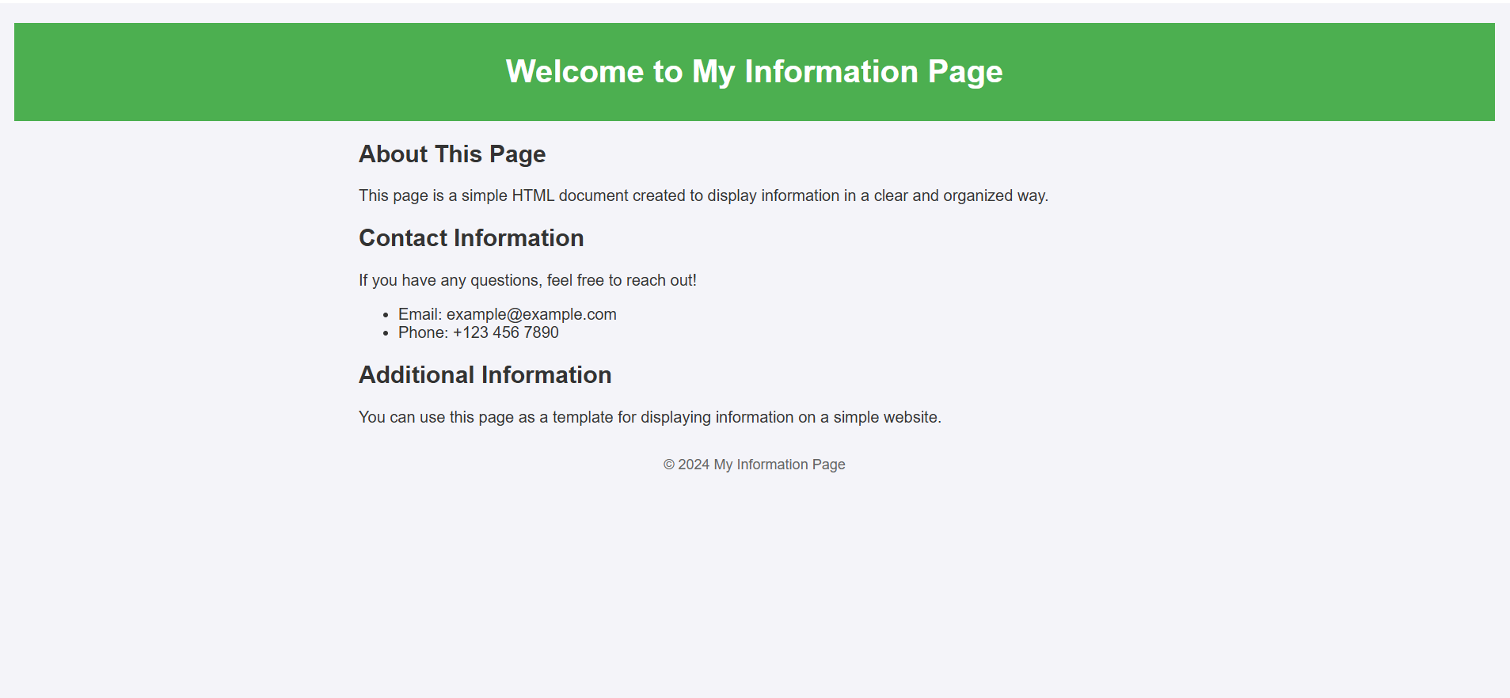

Changes reflected in the CI-CD pipeline:

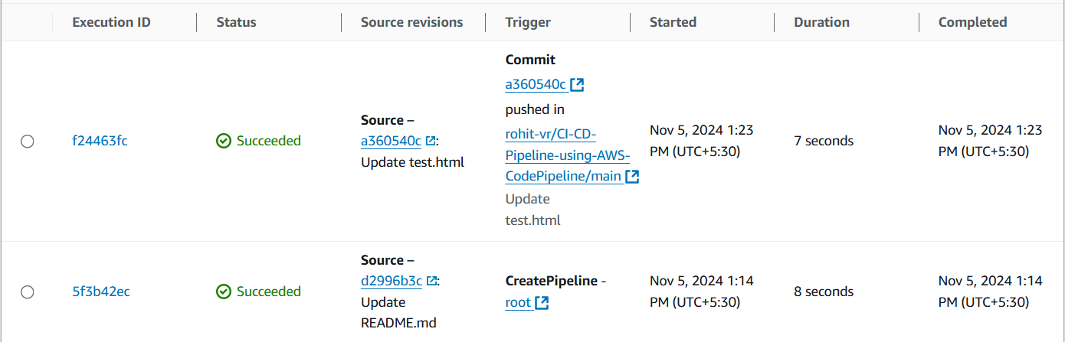

Update to the website captured in GitHub:

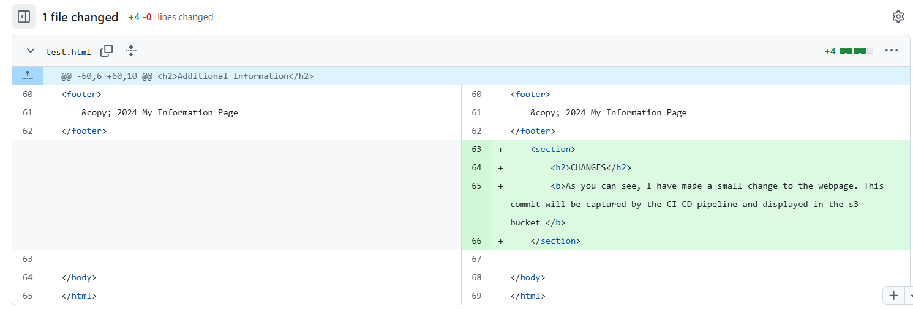

Updated Website:

